**DISTANCE MONITORING SYSTEM**

**Project Description:**

I have designed this project for monitoring the distance between each vehicles in order to avoid some road accidents.as per the government rules every vehicle on road must maintain a minimum of 10m gap between each vehicles. But no vehicle is responding.In order to make the vehicles to follow this device was designed.

**Working:**

Whenever a vehicle is very close to another vehicle on road i.e. (less than 10m gap). This device will indicate the driver through an alarm or voice command.

**Issues:**

This system may function only when the vehicle is on highways or travelling in a average speed. But when the road is in traffic surely all the vehicles will move close to each other. During such trafficable situation this device may create a irritation to the driver by giving alert or voice messages.

**Solution:**

In order to avoid such irritation, this device will work by detecting the gear position, so that this device will deactivate automatically when the vehicle is on traffic and it will reactivate automatically when the vehicle is on highways

|  |  |  |  |
| --- | --- | --- | --- |
| **Traffic Jam** | Device turned off | Gear 1 or 2 | No indication if (D<10m) |
| **Highways** | Device turned on | Gear 3 or more | Indicate if(D>10m) |

**Flow chart:**

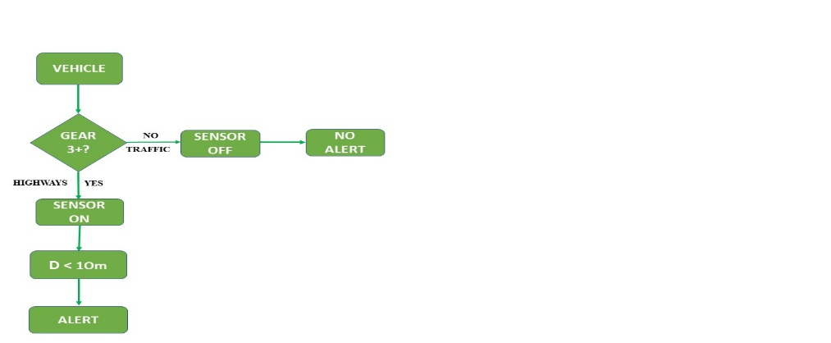

**Hardware Design:**

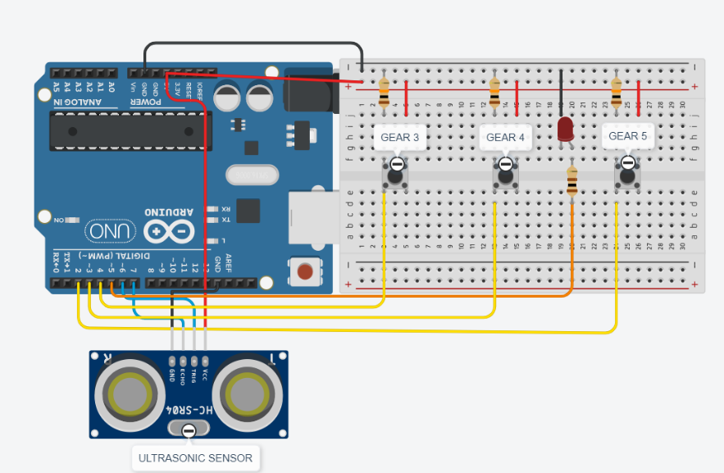

**Output :**

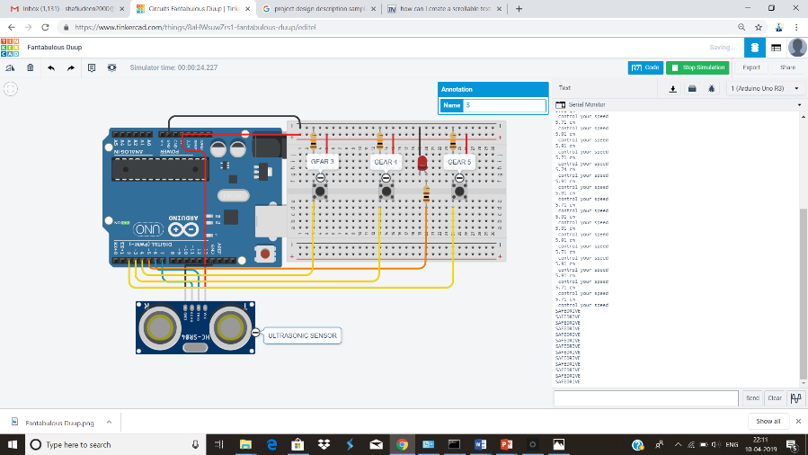

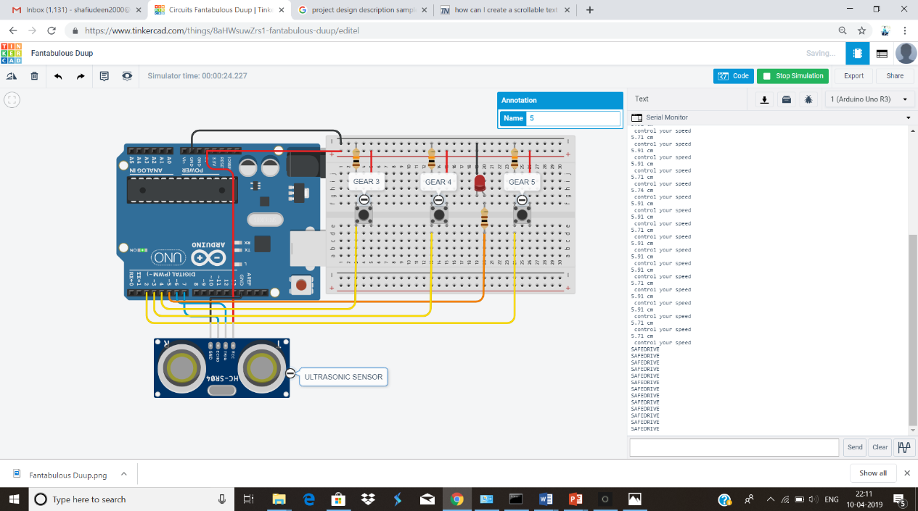

**Simulation link:** <https://www.tinkercad.com/things/8aHWsuwZrs1>

**Designed by:**

**SHAFIUDEEN. M**

**B.E.ECE 2nd Year**

**17BEC031**